Patient Participation Group 2018-19

Date: 12.09.2018
Presented by: Dr Siva, Abhi

Focus: Technology and self-help.
Dr Siva explained that there is much that patients can do themselves. This is not about doctors, nurse and staff at the surgery being lazy.
Rather, it is a way of empowering patients, to take charge of their own health needs.
Moreover, it is the way forward for health care, that patients and their health care teams work together in partnership.
It is known that some things like blood pressure measurements are more accurate when done by people at home. (BMJ 2011)

Patient call system plus Health message replay
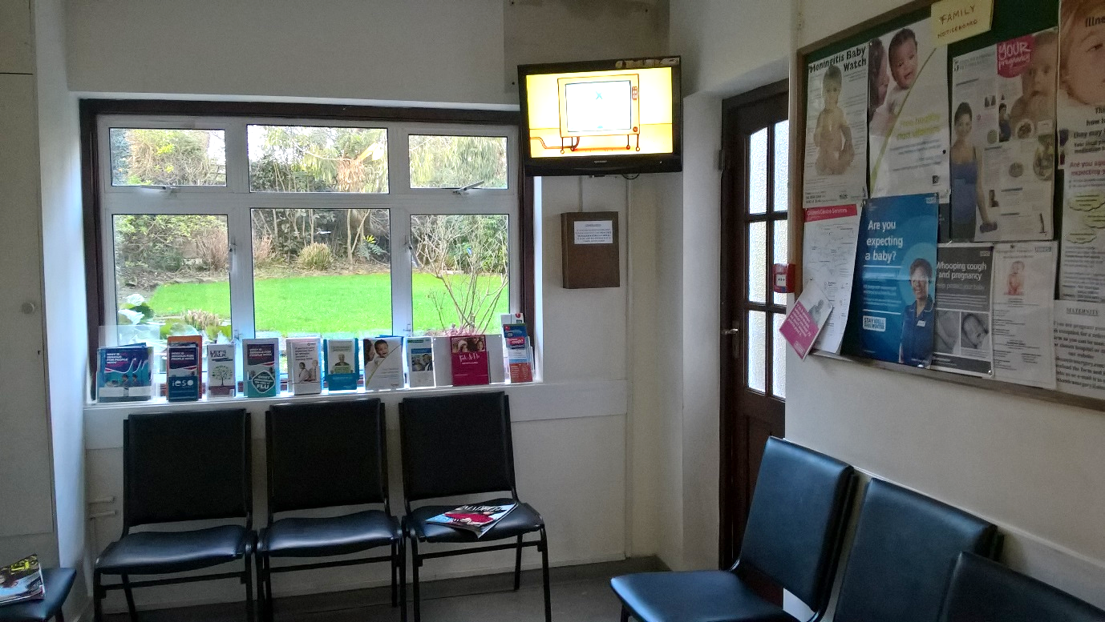

Check-in touch screen, also allows update of contact details
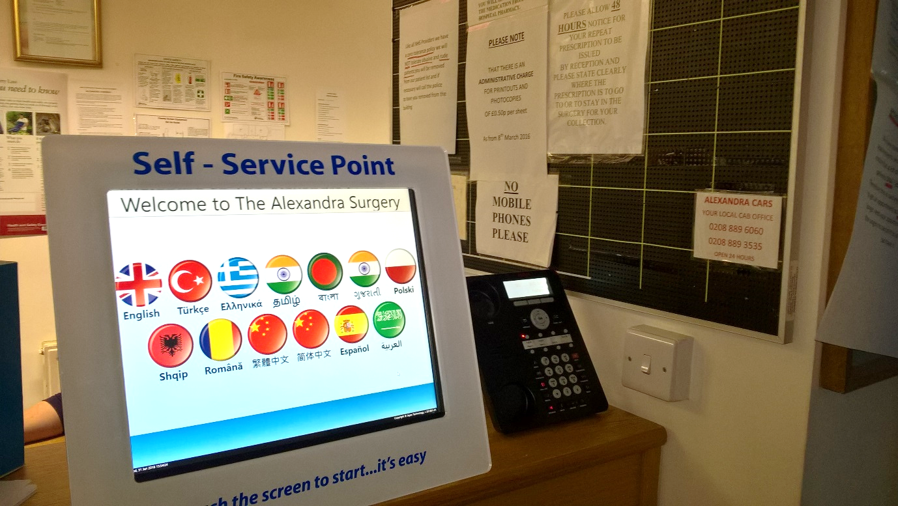

Self-care corner: checking weight, height, blood pressure, with printout record
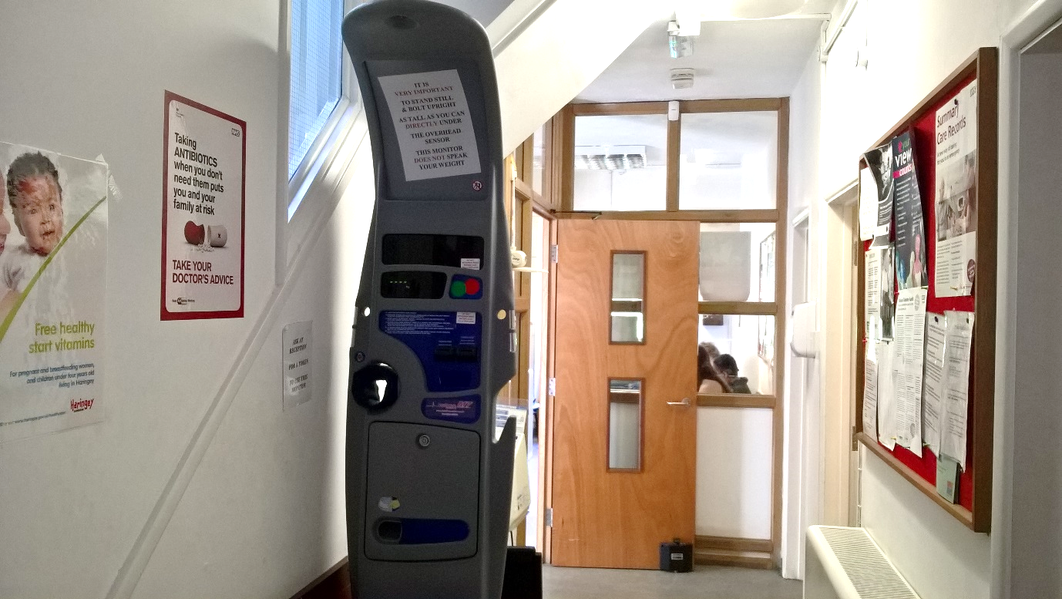

Patient Access online
Abhi explained that this has been available for several years and uptake has been improving.
As of the 28th September:
Total patient list: 5,939
Activated accounts: 3,262 (54.9%)
Invalid accounts: 181

It allows patients to book appointment, request repeat prescription, and view parts of their medical records. Once they have registered, they can use this 24 hours, 7 days a week, even when the practice is not open.
The service is free to use, except for any costs you incur to connect to the internet.
[Please note free NHS Wi Fi is available on the practice premises]

You can log in via the Patient Access website from any computer, tablet or mobile phone. Or you can install an app on your mobile device.
If you forget your password, or enter it wrong three times, you can reset it yourself via email and mobile phone.

To register, please contact the reception staff. If you are new to the practice, we may ask you for some proof of identity.
Registration involves two steps. First obtain your user ID and a code to activate your account. You may then log in once within two weeks, when you can set your password.

We thank you for your attention.

